FACULTY PROFILE
HINDI
DEPARTMENT:
DR.KRISHNA KUMARI
NAME:
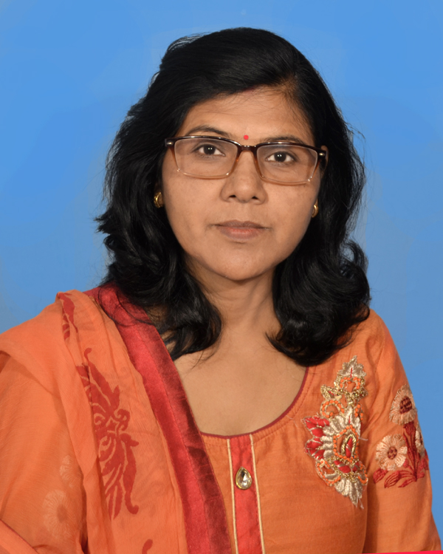
DIGITAL PHOTOGRAPH:

DESIGNATION: | ASSISTANT PROFESSOR
DATE OF JOINING THIS COLLEGE: | 03 MARCH 2008
TEACHING EXPERIENCE [at UG & PG level only]: | 12 YEARS 07 MONTHS
CONTACT NO.: | 8986733361
EMAIL ID: | kumarikrishna860@gmail.com
ACADEMIC QUALIFICATIONS [PG & above only]: | M.A., Ph.D.
SPECIALIZATION/RESEARCH AREA: | SURDAS / egknsoh ds x| lkfgR; esa ukjh&foe’kZ
SUPERVISING RESEARCH SCHOLARS/ PURSUING RESEARCH:
RESEARCH PAPERS/ARTICLES: | Hkkjr dh vuqlwfpr tutkfr vkSj ljdkjh uhfr] vçSy&twu 2017] i`Œ 7&12  egkohj çlkn f}osnh vkSj fgUnh Hkk"kk&lkfgR;] ekpZ] 2019] i`Œ 10&12  AND NATIONAL AND INTERNATIONAL 20 RESEARCH PAPER PUBLISHED IN VARIOUS JOURNALS
EDITED/AUTHORED BOOKS: | - egknsoh ds x| lkfgR; esa ukjh&foe’kZ] vydk çdk’ku] [ktkaph jksM] iVuk&4] 2011]  ISBN : 9788192118413  - jkeujs’k f=ikBh % O;fDrRo ,oa ÑfrRo] vk;q"eku ifCyds’ku gkml] ubZ fnYyh] 2018  ISBN : 978-93-5234-112-2  - t;’kadj çlkn ds ukVdksa dk v/;;u] vk;q"eku ifCyds’ku gkml] ubZ fnYyh] 2018  ISBN : 978-93-5234-155-9  Editor – Journal for Social Reality, U.G.C. Approved Journal, Quarterly (English & Hindi),  ISSN – 2349-9710, Vol. – 4, No. 2
AFFILIATION/ASSOCIATION WITH JOURNALS, etc.: | - fo’ok & varjkZf"Vª; fgUnh lfefr dh =Sekfld eq[k if=dk ¼Life Time Member½  - “Institute for Social Development and Research”, Journal for Social Reality, ISSN – 2349-9710  ¼Life Time Membership No. – LM108½  - “The Intellectual Voice”, ISSN 2581 432X  ¼Life Time Membership No. – LM/AM-0606½  - “INWORD EYE”, (Life Time Member)
MEMBERSHIP/ATTACHMENT WITH DIFFERENT ASSOCIATIONS/INSTITUTIONS/BODIES/BOARDS: | Co-Ordinator – Women Cell St. Columba’s College.  Member of Anti-Ragging committee St. Columba’s College.
ACHIEVEMENTS/FELICITATIONS/AWARDS RECEIVED: | “Bhagwan Buddha Fellowship National Award – 2018”  iap’khy vkJe] >kjksnk ¼cqjkM+h½] fnYyh&84  09&10 fnlEcj] 2018
ANY OTHER RELEVANT INFORMATION: | fofo/k fo’ofo|ky;ksa }kjk vk;ksftr jk"Vªh; ,oa varjkZ"Vªh; lsfeukj ,oa osfcukj esa lfEefyrA

[SIGNATURE]
Dr. Krishna Kumari

